**DAILY ONLINE ACTIVITIES SUMMARY**

|  |  |  |  |  |  |  |  |  |
| --- | --- | --- | --- | --- | --- | --- | --- | --- |
| **Date:** | 08-06-2020 | | | | | **Name:** | D Richard Franklin | |
| **Sem & Sec** | Fourth sem section A | | | | | **USN:** | 4AL18CS020 | |
| **Online Test Summary** | | | | | | | | |
| **Subject** | | Complex analysis, probability and statistical methods | | | | | | |
| **Max. Marks** | | 30 | | **Score** | | | 20 | |
| **Certification Course Summary** | | | | | | | | |
| **Course** | 1. Introduction to Cyber Security | | | | | | | |
| **Certificate Provider** | | | greatlearning | | **Duration** | | | 3 hr |
| **Coding Challenges** | | | | | | | | |
| **Problem Statement:**  1: Program to sort an array having only 0s, 1s and 2s | | | | | | | | |
| **Status:** completed | | | | | | | | |
| **Uploaded the report in Github** | | | | | yes | | | |
| **If yes Repository name** | | | | | <https://github.com/alvas-education-foundation/Richard_Franklin> | | | |
| **Uploaded the report in slack** | | | | | yes | | | |

**Online Test Details:**

It was about the topic from module 2. The questions were all multiple choice questions which were optimal and easy to solve. The score that I got was 20/30.

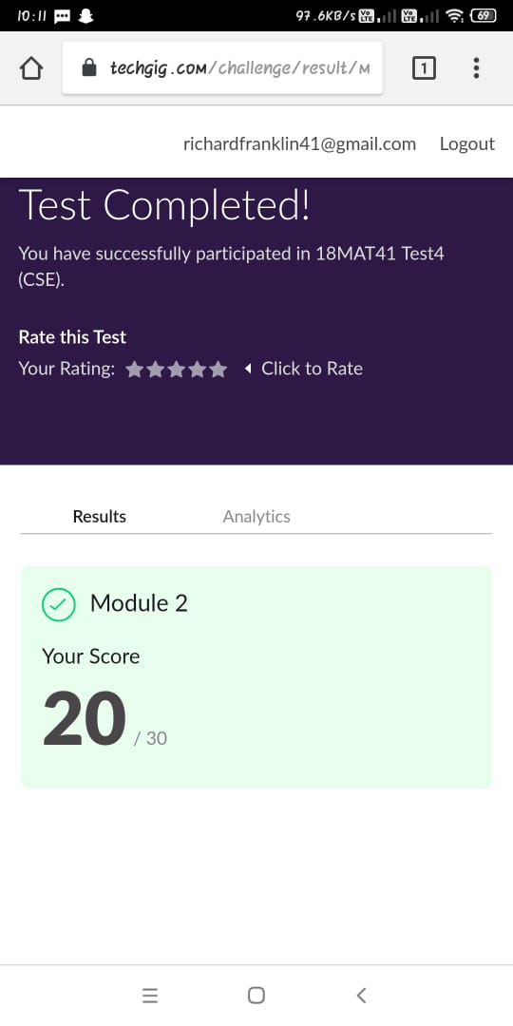

**Online Course Details:**

1. Name of course: **Introduction to cyber security**

Certificate provider: greatlearning

The total course was about the importance of cyber security. The course had details regarding how blockchain is used in cyber security, how it is used in career and industry landscape, its governance and risk and many other important details regarding the same.

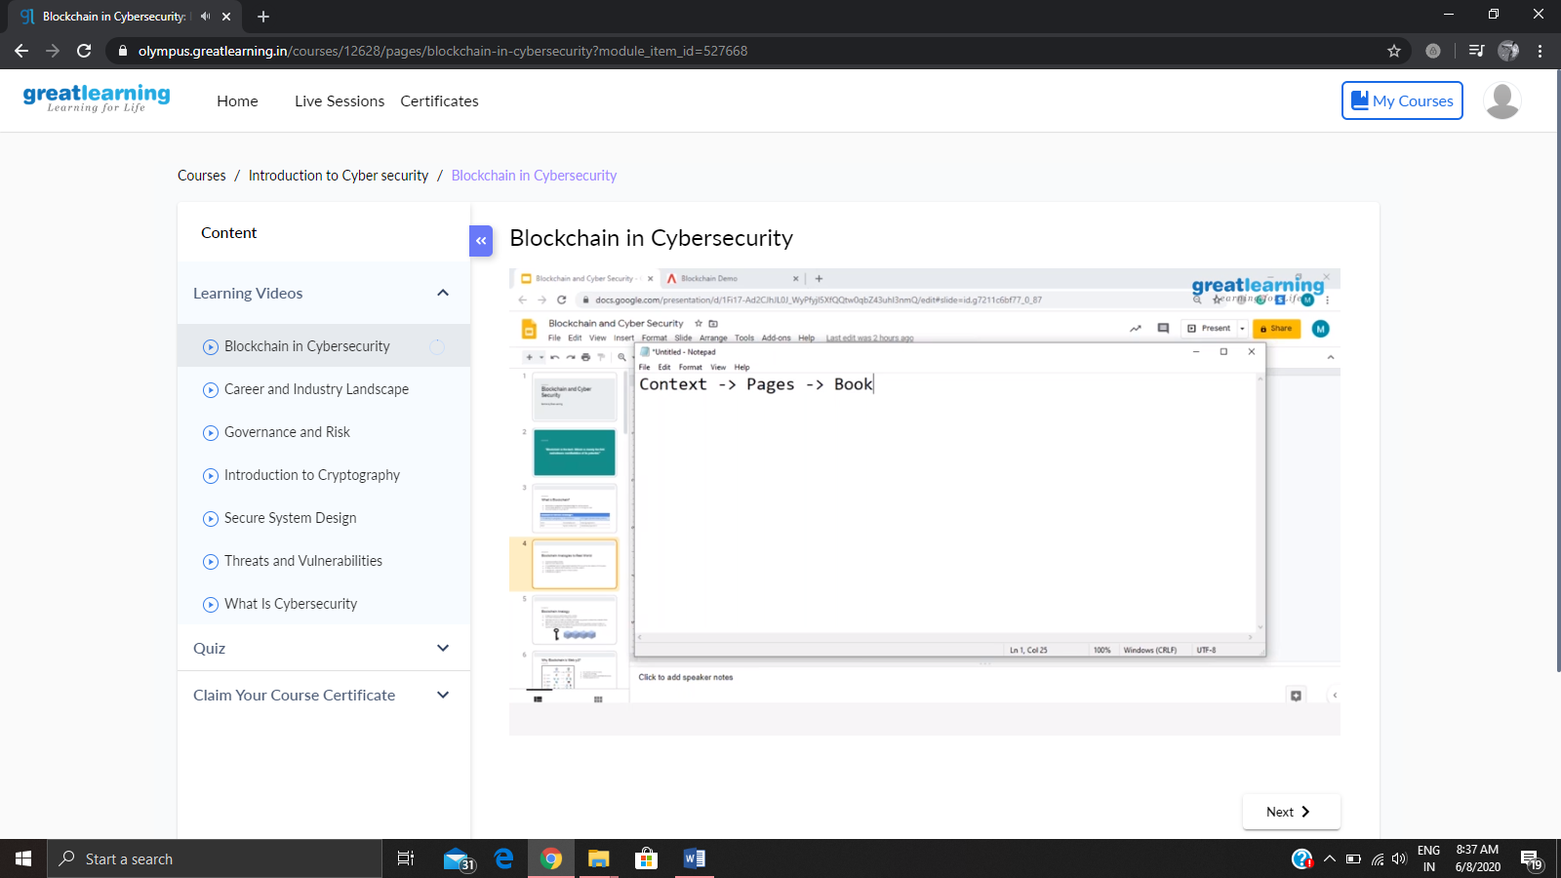

**Online coding:**

Problem 1: (using java) program to sort an array having only 0s, 1s and 2s

